Assessment: Lab Exercise 2

Student Name: Zahi Masarwa

Lab Professor Name: Mel Sanschagrin

Lab Section Number: *303*

Due Date: 01/29/21

1.By default, many of the methods in class math call the equivalent method in ________?

(One class name)

StrictMath

2.What is the field PI in class Math?

The field Pi in class Math represents the double value that is closest to the value of *pi*.

3.What method would let me calculate a square root of a number?

public static double sqrt(double a)

4.What method would return the result of calculating the power of a number, most

calculators depict this operation as x?

public static double pow​(double a, double b)

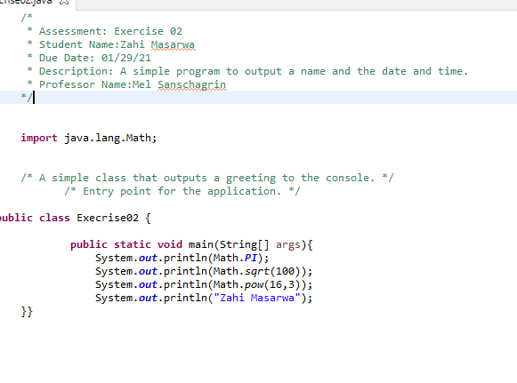

# References / Sources Cited <<optional section, if needed>>